**How can I be more like Carlo?**

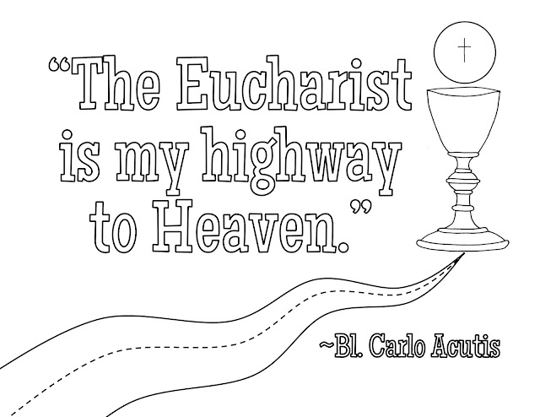

**Make the Eucharist the Centre of Your Life**: Like Carlo, we are called to make the Eucharist the “highway to heaven.”

*In what ways do I or could I stay close to God? This might be attending Mass more regularly, spending time in Eucharistic Adoration, or other ways through which we can deepen our relationship with Christ.*

*……………………………………………………………………………………………………………………………………………………………………………………………………………………………………………………………………………………………………………………………………………………………………………………………………………………………………………………………………………………………………………..*

**Share the Faith**: Carlo used his talents to spread awareness of the Eucharist and Eucharistic miracles.

*How do I use my gifts and talents to share the faith with others, whether through personal conversations, writing, or digital media?*

*……………………………………………………………………………………………………………………………………………………………………………………………………………………………………………………………………………………………………………………………………………………………………………………………………………………………………………………………………………………………………………..*

**Embrace Holiness in Everyday Life**: Carlo’s life shows us that holiness is possible, even in the ordinary moments of life. Whether playing soccer, spending time with friends, or working on his computer, Carlo lived with a constant awareness of God’s presence.

*How can I use every opportunity to grow in holiness and love?*

*……………………………………………………………………………………………………………………………………………………………………………………………………………………………………………………………………………………………………………………………………………………………………………………………………………………………………………………………………………………………………………..***Trust in God’s Plan**: Despite his illness, Carlo offered his sufferings for the Church and trusted in God’s plan for his life.

*At times of difficulty or uncertainty in my life where, what could I learn from Carlo’s example?*

*……………………………………………………………………………………………………………………………………………………………………………………………………………………………………………………………………………………………………………………………………………………………………………………………………………………………………………………………………………………………………………..*

